Kindred Job Description
Role Title: | Regional Manager
Reports to: | Senior Regional Manager
Staff reporting to this position: | Cleaning Supervisors/Site Managers

About Kindred
At Kindred, we are focussed on our people, our community and our environment. One of our key priorities therefore is to create a positive and inclusive environment for all individuals. As an equal opportunities employer, we firmly believe in giving full and fair consideration to all applicants, without discrimination based on age, disability, ethnicity, sexual orientation, sex, gender reassignment, socio-economic background, religion or belief, marriage and civil partnerships, or pregnancy and maternity.

Our values

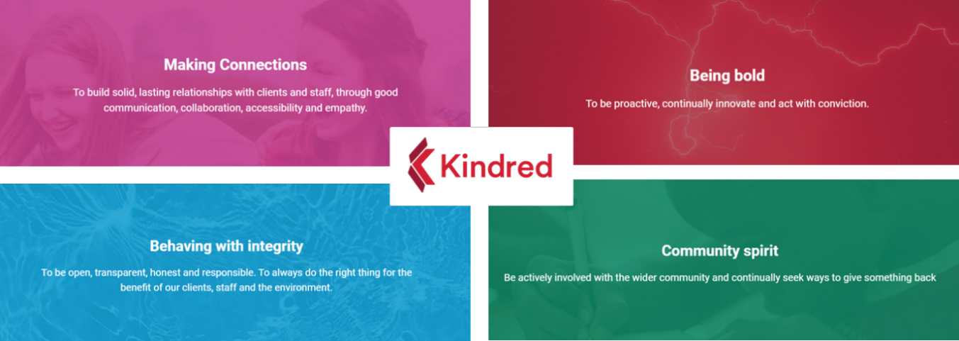

Role Overview:
The Regional Manager role is responsible for managing a team of supervisors and operatives, ensuring all the sites are properly supervised and that the specified cleaning standards are met and maintained to a high level.
The successful applicant will be required to undertake an enhanced Disclosure and Barring Service (DBS) check to our satisfaction. This is a criminal background check to make sure you are permitted to work on our sites.

Key Responsibilities
- Managing the team on site to ensure great service delivery whilst delivering maximum contract profitability
- Ensuring all budgets are adhered to
- Maintaining strong client relationships with high levels of satisfaction
- Providing and maintaining the quality of service delivery
- Managing, recruiting, and coaching the teams on your sites
- Conducting monthly quality audits at each of the sites you are responsible for
- Carrying out ad-hoc and regular activities such as projects, reports, as required by and to support the Operations Manager.
- Holding regular contract and specification review meetings with customers
- Being responsible for ensuring Health & Safety procedures and legislation is adhered to
- Looking for opportunities for continuous improvement, cost savings and account growth.
- Seeking opportunities to sell in additional services

Requirements, Skills & Experience
- Excellent communication and people management skills
- Strong leadership and motivational skills, with the ability to forward plan, work under pressure and influence at a senior level
- Experience with managing, budgets
- Working knowledge of Health and Safety systems in the cleaning industry
- Ability to work to tight timescales
- Experience working with education clients previously would be highly desirable
- Passionate, flexible, trustworthy, and innovative.
- Hold a full driving license and be able to travel to sites
- Basic Excel, Word & Outlook skills

Qualifications Desired
Appropriate professional qualifications and/or memberships. For example, any British Institute of Cleaning Science (BICSc), Institution of Occupational Safety & Health (IOSH) or National Examination Board in Occupational Safety & Heath (NEBOSH) memberships, qualifications, or specific course attendance.

Our Benefits
- 24/7 online GP access providing confidential medical advice at a time that suits you.
- Health Cash Plan to support with everyday healthcare expenses.
- Death in Service (4x annual salary) providing financial security for dependents.
- Team volunteering days enabling employees to support community and charitable initiatives.
- Two annual company-wide training days focused on professional development and capability building.
- Two annual company-wide social events designed to strengthen collaboration and engagement.
- Birthday leave allowing employees to take time off to celebrate their special day.
- Opportunities to participate in corporate fundraising activities in support of our partnered charity.
- Above and Beyond Reward Scheme rewarding exceptional contribution and performance

Minimum Criteria Disclosure
We give full and fair consideration to all applicants. We will interview everyone who has declared they have a disability, or has served or is serving in the armed forces, if they meet the minimum criteria for the position

Minimum Criteria
- Able to manage and support multiple sites, teams, and operational functions, with reasonable adjustments if needed.
- Able to understand, implement, and monitor business objectives, operational procedures, and compliance requirements independently.
- Complete management and operational tasks accurately within agreed timescales and quality standards.
- Able to communicate clearly, confidently, and professionally in English (spoken and written) with team members, peers, and senior leadership.
- Able to commit to the required working hours and travel between sites within the region (reasonable adjustments considered where necessary).

Additional Information
Kindred are proud to be a bronze holder of the Defence Employer Recognition Scheme.
Kindred is a disability-confident employer and welcomes applicants from all backgrounds. We will support any reasonable adjustments to ensure a safe and inclusive working environment.

Contact Us
If you wish to disclose confidentially that you have disability or are an armed forces veteran, please email: recruitment@kindredfm.com
If you require reasonable adjustments to be made during the recruitment process, please also use the same email address.

The duties and responsibilities described above are not a comprehensive list and additional tasks appropriate to the role may be assigned to the employee for time to time.

Signed…………………………………………………………… Date:…………………………………………………………..
Employee’s Name:
