Job title | Food & Beverage Team Member
Candidate Brief | NOW Group are an award-winning social enterprise who deliver services across the Island of Ireland supporting people with learning difficulties, autism and neurodiverse conditions into jobs with a future.  The organisation was established in Belfast and expanded over the last twenty years throughout Northern Ireland to provide services to support people into employment, training, transition, volunteering and a family service.  Our Café in Kilmainham Square Dublin 8 is our newest member to the Loaf Family. The Café has become a go to spot in the local area for residents, commuters and Tourists. We are now ready to drive our business to the next level, establishing ourselves with corporate catering to businesses in the local area and beyond.  As a Food & Beverage Team Member you will assist with the preparation of food in and work with the Loaf team to produce an exciting brand which promotes healthy eating while creating training and employment opportunities for local people with learning difficulties.
Location | Loaf Cafe, Unit 2 Building 1, Old Chocolate Factory, Kilmainham Square, Inchicore Rd, Kilmainham, Dublin 8,
Reports to | Hospitality Operations Manager
Hourly rate: | €14.15 per hour
Hours | Adhoc across Monday to Friday

Mission

Supporting people with learning difficulties and autism into jobs with a future.

Vision

A society where people with learning difficulties live, work and socialize as valued citizens.

Main Responsibilities

- Inspire and support NOW Group catering students through provision of training and assessment opportunities in conjunction with training staff.
- Deliver food and drink to our visitors, to the Loaf standard.
- Prepare food to the standard required by Loaf.
- Cleaning of the kitchen, it’s surrounds and equipment to a high standard.
- Adhere to existing work practices, methods and procedures.
- Undertake relevant training and development activities and respond positively to new and alternative systems.
- Maintain confidentiality and observe data protection and associated guidelines, where appropriate.
- Provide high levels of customer service to café and function catering customers.
- Ensure security and safety of staff, participants, premises, stock and cash at all times.
- To follow Health and Safety Regulations including Fire, Hygiene H.A.C.C.P and C.O.S.S.H.
- Carry out any other reasonable duties within the overall job function.

This job description in not definitive and may be subjective to review as the duties and the responsibilities determine. Please note that employment with NOW Group may be subject to a check from the Garda Vetting Bureau

Personnel Specification

Skills & Experience

Essential
- Ability to work under pressure
- A can –do attitude.
- Ability to work evening/weekends as & when required.
- Previous experience (paid or voluntary) of working in a busy catering environment.

Desirable
- Barista trained.
- Essential Food Hygiene Certificate
- Experience of keeping records
- Knowledge and understanding of the needs of disabled people and a commitment to the equal rights.
- Experience of dealing with customers.

Values & Behaviours

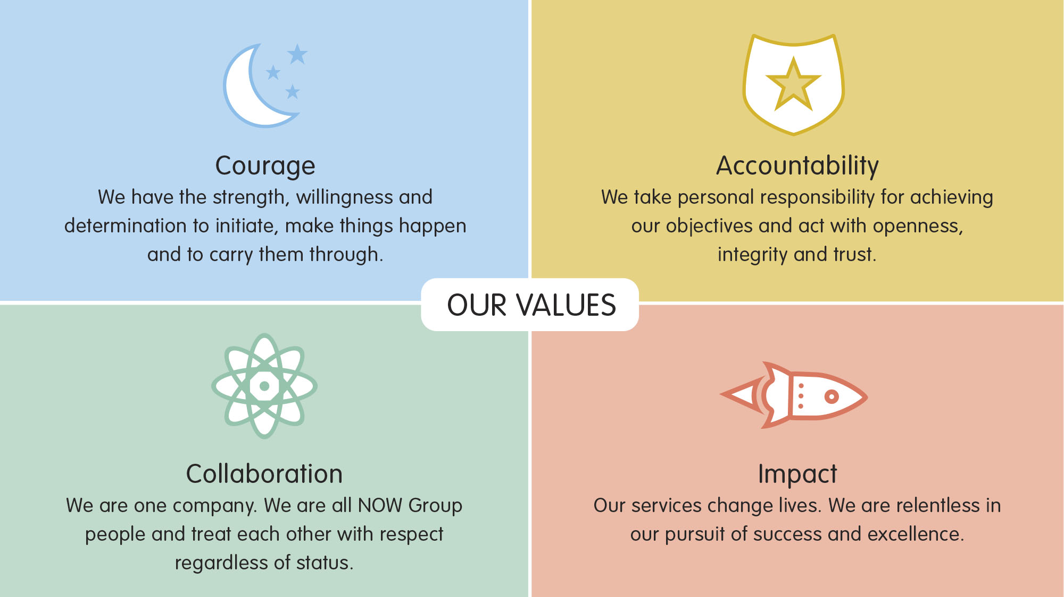

All employees in NOW Group are required to subscribe to the values of the organisation and demonstrate these values through agreed behaviours in their day to day work and their relationships with participants, stakeholders and colleagues. Candidates will be expected to demonstrate relevant values and behaviours as part of the interview process.

