Job title | Food & Beverage Team Leader
Main Function | We are Loaf Catering, we are a social enterprise supporting people with learning difficulties and autism into jobs with a future.  We deliver outside catering for events across Greater Belfast. Our flagship building Loaf Café on the Grosvenor Road is where the magic happens, here we have a food preparation and production unit for all outside catering and supplies to our other sites.  We have an exciting opportunity for a passionate Team Leader to join our team. The successful candidate will have a love for food, a keen eye for detail and a passion for training and developing our participants. This is a fast-paced catering business with a real purpose. You will support the Food & Beverage Manager in the day to day running of this café to make sure everything meets our high standards.
Location | The Bobbin Café in the City Hall
Reports to | Food & Beverage Manager
Hours | 40
Salary scale | £29,000
Benefits | 25 days annual leave plus 12 statutory days (pro-rata)  Health Cash Plan (on successful completion of probationary period)  Access to confidential Staff Counseling & Financial Advisory Services  Stakeholder Pension Scheme (5% employer contribution)  Bike to Work Scheme  Holiday purchase scheme  Flexible working initiatives  Wellbeing initiatives

Mission
Supporting people with learning difficulties and autism into jobs with a future.

Vision
A society where people with learning difficulties live, work and socialise as valued citizens.

Main Responsibilities

- Bring your love of food and great service to our café and use that passion to not only make sure our café is presented to our high standards, and that we give the highest quality of service that we are recognised for, but also share that passion for excellence with our participants.
- Using your knowledge of food safety and allergens, you will make sure that the site meets our high standards and that all paperwork is complete to ensure our customers, participants and team stay safe.
- With your keen eye for detail, you will make sure that all food leaving the kitchen meets our brand and quality standards.
- Because you understand business too, you will help us make this business profitable, you will support the management team in achieving our financial targets; sales, gross profit and control of labour.
- You are a people person, you lead by example, you manage a tight ship with a drive for results. You will support your team to ensure they share this vision too.
- We want to be the best, and we want to have the best team. Your development is as important to us as it is you. We have some training that you will need to complete, but we are also keen to support in any other training that may support you in your development.

This job description is not definitive and may be subject to review as the duties and responsibilities determine.

Personnel Specification

Essential

- Experience working at a supervisory level in a catering/hospitality environment.
- An understanding of Health and Safety procedures including COSHH and HACCP
- Experience of providing excellent customer service.
- Experience of cash handling, stock and portion control and meeting GP targets.
- Ability to work weekends and evenings.

Desirable

- A supervisory qualification.
- NVQ Level 2 in Catering and Hospitality.
- Customer Care qualification.
- Essential Food Hygiene Certificate.
- Barista experience.
- Experience of working with adults with learning difficulties.

NOW Group adhere to the AccessNI Code of Practice and it is our policy to obtain an Enhanced Disclosure for employees who will be working within our service delivery teams. This check will be completed before employment commences and only if successful at interview. For further information please refer to the Access NI Code of Practice at AccessNI Code of Practice (nidirect.gov.uk)

A copy of our policy on the secure handling, use, storage and retention of information is available on request.

In line with the Rehabilitation of Offenders (Exceptions)(NI) Order 1979 (as amended in 2014), NOW Group’s will only ask about convictions which are defined as “not protected” for the purposes of obtaining a Standard or Enhanced disclosure. Please note that a criminal record will not necessarily be a bar to obtaining a position. A copy of our policy on the Recruitment of Ex-Offenders is available on request.

Values and Behaviours

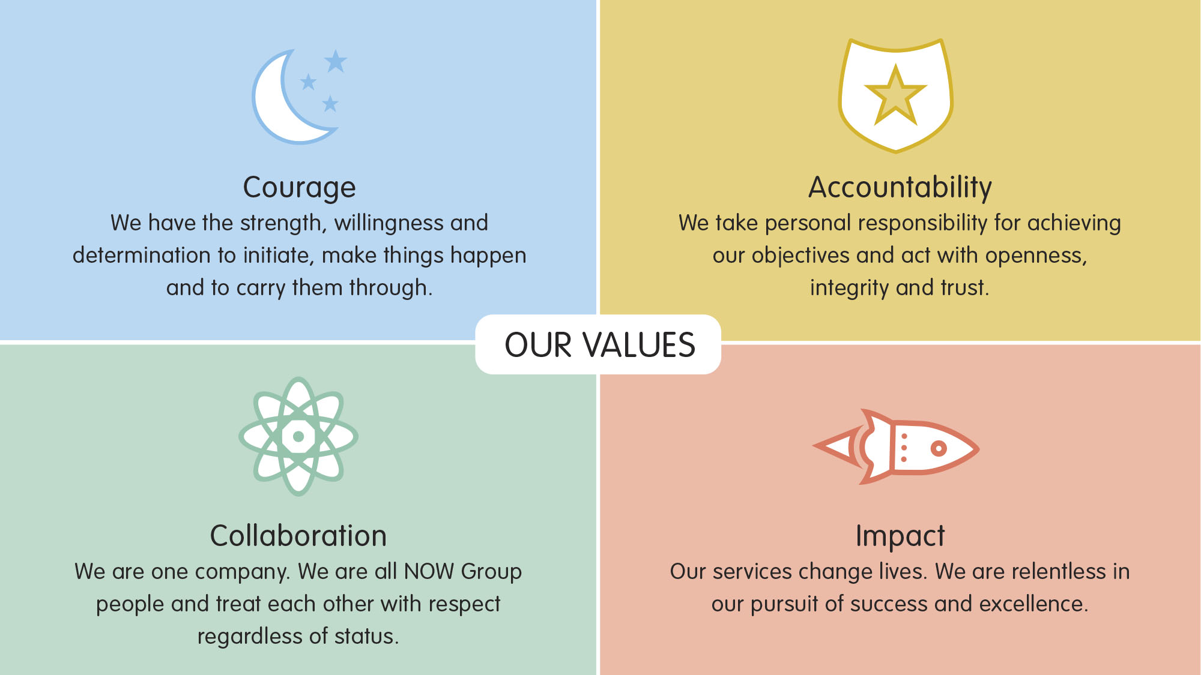

All employees in NOW Group are required to subscribe to the values of the organisation and demonstrate these values through agreed behaviours in their day to day work and their relationships with participants, stakeholders and colleagues. These are displayed on the next sheet.

Candidates will be expected to demonstrate relevant values and behaviours as part of the interview process.

NOW Values | Behaviours -All Staff | Behaviours -Managers
Courage  We challenge convention, ourselves and each other. We have the strength, willingness and determination to initiate, make things happen and to carry them through. | Takes practical approach to problem solving, proposes solutions rather than presenting problems | Demonstrates creativity and innovation in development of solutions
 | Uses initiative | Has confidence to address difficult situations using effective negotiation skills with internal and external stakeholders
 | Is resilient, flexible and embraces change | Embraces organisational change and supports staff to see it through to implementation
Accountability  We are all champions of NOW Group. We take personal responsibility for achieving our objectives. We act with openness, integrity and trust. We ask for help, admit to our mistakes and put things right. | Committed to learning and developing in work | Is accountable for team performance, setting clear but challenging objectives which stretch develop and motivate staff
 | Is open and honest when things don't go to plan. Reflects on own practice to improve | Adheres to organisational guidelines in management of contracts, funds, data and personnel
 | Takes responsibility | Acts as a strong role model for team, demonstrating commitment to the organisation and its leadership
Collaboration  We are one company across all services and locations. We work towards a common goal through cooperation and teamwork. We are all NOW Group people and treat each other with respect regardless of status | Is a strong team member, supportive of all colleagues and flexible. | Supports other teams and managers taking a corporate approach to meeting organisational objectives
 | Communicates well with colleagues in other teams, shares ideas and knowledge | Communicates effectively to team to build trust and break down barriers
 | Is an Ambassador for NOW and actively promotes all areas of the business | Engages a range of customers and stakeholders using external networks to ensure organisational growth and success
Impact  Our services change lives. We listen to our participants*, their families and communities and use continuous improvement to deliver results. We are relentless in our pursuit of success and excellence. (*also external and internal customer) | Looks for and suggests ways to improve own and team performance | Committed to delivering high quality services through continuous improvement of own service
 | Puts the participant/customer at the heart of service delivery, delivering services that make a difference | Seeks and uses feedback from participants/customers to make improvements to service delivery
 | Always delivers to highest quality | Seeks and uses relevant data to measure impact of service

